NEW TO CHEER? Thinking about signing up?
HERE’S A RUN DOWN OF IMPORTANT INFORMATION:

Registration: March 1st ($60 due upon registration-includes team bow)
**Closes April 1st: Depending on the # of registrants this date could close sooner, so register ASAP to claim your spot.
*Per our LYF bylaws there is a 1:10 coach/cheer ratio, most of our teams have 2-3 coaches, we may need to close off some squads based upon this for satisfaction & safety reasons.

Uniforms: Fitting date is Fri. May 12th in the LECC gym (indiv. squad times TBD).
COST: $240.20 + tax for new registrants who need the whole package. Package includes: shell, skirt, socks, shoes, midriff, brief, poms. Buying the package is more cost efficient than trying to buy a la carte. Jacket is optional and an additional cost ($59.95)
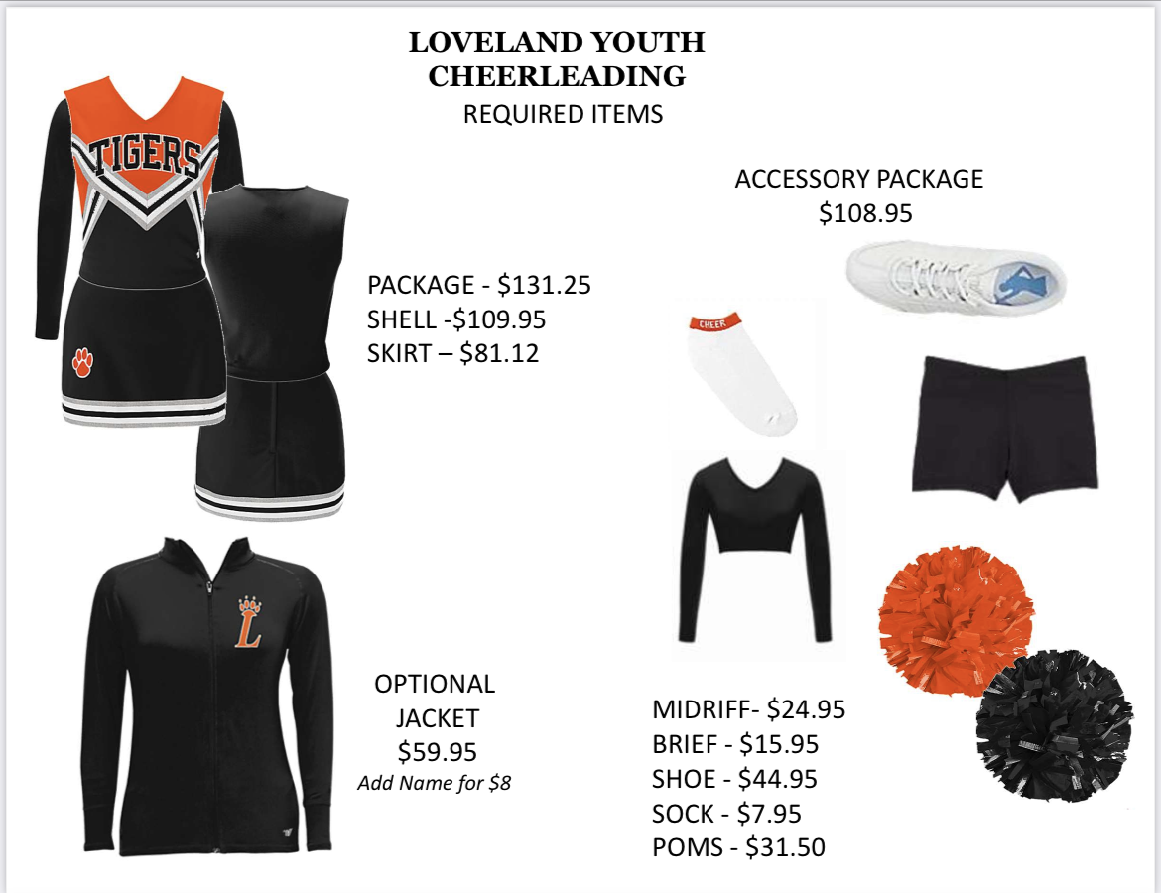

Returning cheerleaders: Same uniform as last season! If any of your uniform items don’t fit, please turn them in to me by April 23rd (drop off: 11667 Kosine Dr.).. Any items you wish to sell need to be clean, bagged & labeled (childs name, grade, email and size of each item). The sale will be done in the LECC gym May 1st (4:30-6pm) & 3rd (5-6pm). Cash and check only.

LHS Lil Cheer Camp:July 31st-August 3rd.. COST: $40 6-8pm LHS Main Gym
This event is very important for our cheerleaders to attend. We will be learning material that will be performed at the annual Youth Night. Cheers, chants, dances, fight song, motions, jumps are just some of the fun things the HS cheerleaders will be teaching our lil’s.
Register: https://www.lovelandsummersportscamps.com/

Practice: Typically starts the week after Lil Cheer Camp, younger grades start at the end of July. Your head coach will communicate this. 1-2 practices a week for 1-1.5 hours. Practices usually drop down to 1 practice a week, once school starts, OR once most of the material is learned that is needed for the season, this will vary per squad. Team Fees: $50-$75 ish. This cost is dependent upon squad size and is used for Homecoming, Youth Night, football gifts, team shirts, end of season party, etc.

Games: Start mid August and are mostly on Saturdays, with an occasional Sunday here and there. K/1 starts in the morning around 9-10am and goes from there by grade every hour & 20 min. We cheer rain or shine, all decisions are made by the head coach on cancellations.

Volunteer Obligations: Parents of participating athletes are REQUIRED to sign up for 2 concession/gate duties per season, per athlete for home games. This is how our program makes money! We can’t do it without you! Team moms will keep track of parent signups per grade level.

This is most of the important information in a nutshell, but everything will be communicated by me to the head coaches of each squad. Any questions please don’t hesitate to reach out: lyfcheerat@yahoo.com

Remember to follow us on Facebook for the most up to date information!! LYF Cheer Page.
GO TIGERS!!

Cheers *\o/*,
T & Andrea

